**Part I**

**Chronological modelling using OxCal**

**Dr Rachel Wood**



**Contents**

OxCal 3

Section 2: Calibration of a single radiocarbon date in the Output module 4

Ex1.1: Calibration using the IntCal13 (atmospheric calibration curve) 4

Ex1.2 How to view your calibrated date 4

Ex1.3: How to save and download a plot 5

Ex1.4: How to calibrate a radiocarbon date from the southern hemisphere 7

Ex1.5: How to calibrate a radiocarbon date from a marine environment 7

Section 2: Calibration of multiple dates using the Input module. 8

Data 8

Ex2.1: How to open the Project Manager 8

Ex2.2: How to enter multiple dates into the Project Manager 8

Section 3: Production of a multiphase model 11

Ex3.1: Input of a model 11

Ex3.2: Saving your input file 13

Ex3.3: Outlier analysis 14

Ex3.4 How to run a model 16

Section 4: Viewing and assessing the model 17

Section 5: Age depth models (P_Sequence) 19

Ex5.1 Anteojos: an age-depth model, with excellent agreement between ages and prior assumptions 19

Ex5.2 Chumbrumba: Including 210Pb ages and a change in sedimentation rate 23

Ex5.3 Lake Kutubu: Dealing with a reservoir effect 27

Ex5.4 Palau: A model which does not converge properly 29

Section 6: Model Queries 33

# OxCal

OxCal can either be downloaded or run online. It is generally better to run it, and save all files, on the online version as this is constantly updated.

It is divided into 3 sections:

**Project manager**

* Calibration of multiple dates
* Input of Bayesian models
* Uses Chronological Query Language 2 (CQL2), a language written specifically for OxCal. In this worksheet anything written in CQL2 is written in the Courier script.

**Analysis module**

* Uses a Monte Carlo Markov Chain method to undertake the analysis in C++. This generates a probability distribution by repeated random sampling.
* The analysis itself is not visible and you will just see an image indicating how the modelling is progressing (this is actually part of the Output module).

**Output module**

* The ‘opening’ page
* Calibration of single dates
* Presentation of the results

A manual is found under the Help tab

* Instructions on how to input, analyse and view data
* Link to the OxCal discussion group
* Bibliography

Please note that is possible to bias your model, so if in doubt consult an experienced user (and experienced users ask other experienced users…). There is an OxCal discussion group where you can ask how to use something if you get really stuck, are unsure on whether your model is biasing your results or have an unusual application. Christopher Ramsey (who wrote the program) and his post-docs and collaborators keep a very close eye on the page – so this is an excellent place to get reliable feedback.

**Notes:**

Keyboard shortcut keys do not work in OxCal. You must use the menu bars.

I find Google Chrome works best. The graphics codes do not work well in Internet Explorer.

‘PDF’ means probability distribution function.

# Section 2: Calibration of a single radiocarbon date in the Output module

### Ex1.1: Calibration using the IntCal13 (atmospheric calibration curve)

* Enter a date of 30000+/-400 BP (lab code SANU-4000)
* Press Calibrate

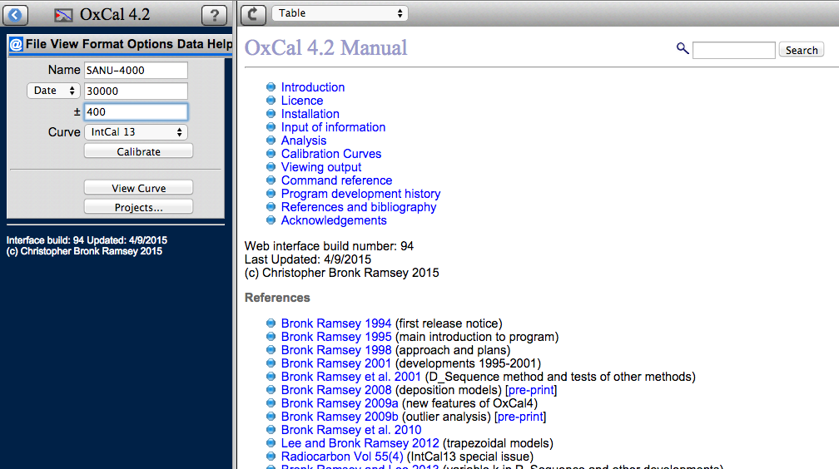

### Ex1.2 How to view your calibrated date

The default view is a table which gives the calibrated date range at 68.3% (34436 – 33771 cal BP) and 95.4% (34817 – 33464 cal BP) probability.

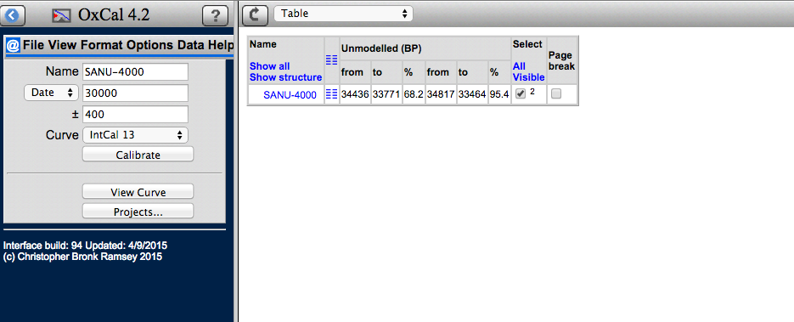

Using the Format menu you can change what data is given in the table.

* Using Format => Show change the calibrated dates from a cal BP to a cal AD/BC timescale (or vice versa).
* Using Round you can round the dates to the nearest 5 or 10 years.
* If you would like to switch between the whole range and the breakdown of the different calibrated ranges, use Whole Range. (try some Holocene dates and you will see the difference).

The date can be viewed in different ways. There are two nearly identical menus in View and in the scroll down list on the right hand side of the screen.



* Use either menu to view the calibrated date as a:

1. Single plot
2. Plot on curve

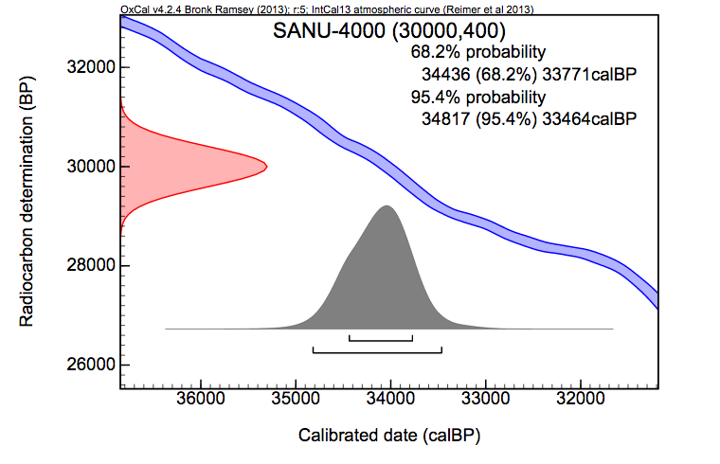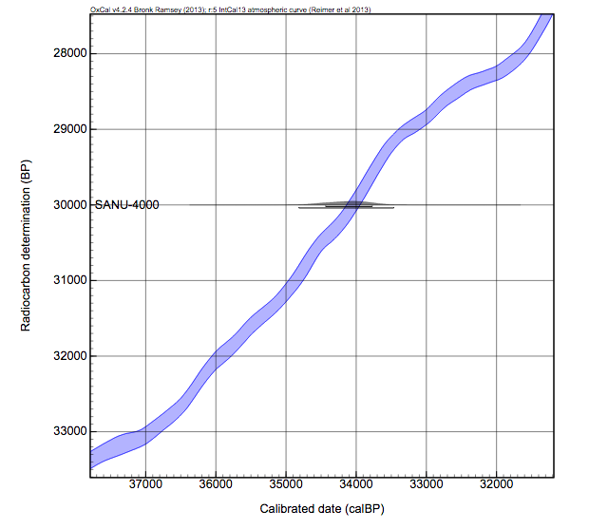

On both images the brackets beneath the probability distribution represent the 68.3 and 95.4% probability ranges.

### Ex1.3: How to save and download a plot

* To save the output File => Save as (a new screen will open). Create a folder, assign a name, and press Save.
* To download, press Download.



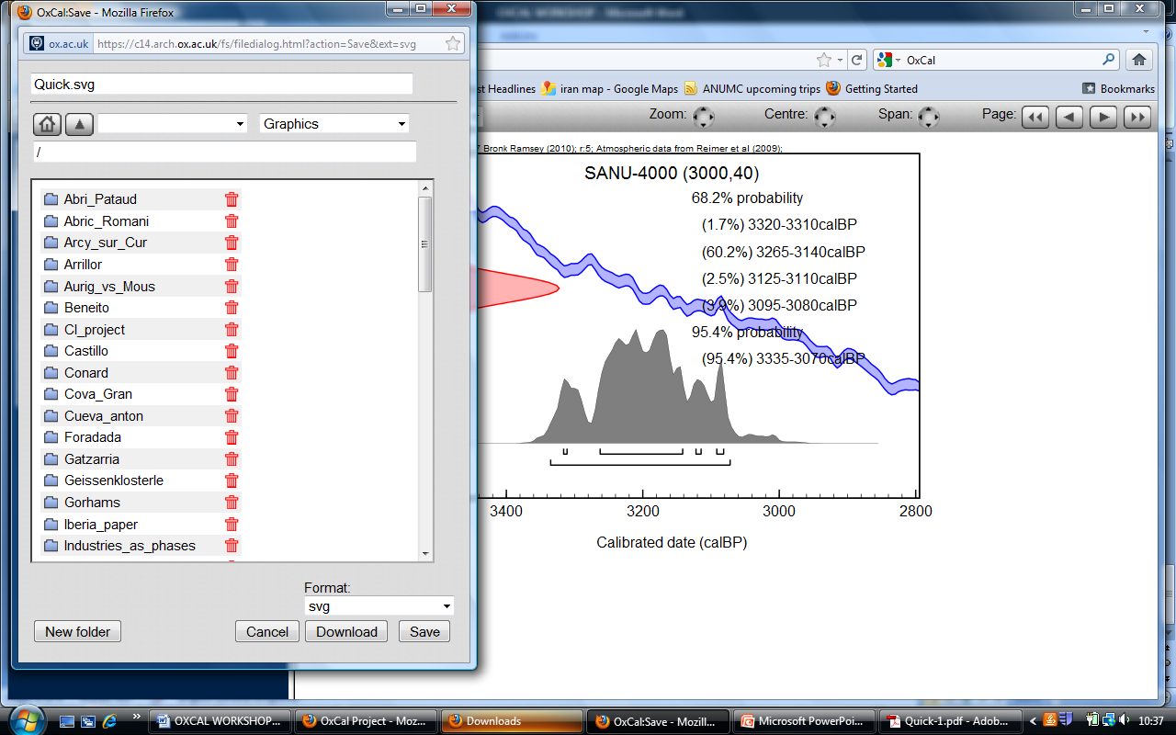

Tables are saved and downloaded as .csv files which can be read by Excel.

Using the scroll down ‘Format’ list, you can download the image as a .pdf, .png or .svg. Good publication resolution images can be obtained using the .svg files. These can be read by and modified in e.g. Illustrator and Inkscape (free to downloaded).

### Ex1.4: How to calibrate a radiocarbon date from the southern hemisphere

The southern hemisphere has a slightly lower concentration of 14C than the northern hemisphere because there is more ocean. **IntCal013** describes the concentration of 14C in the northern hemisphere, **SHCal13** the southern hemisphere. The difference is of the order of 10’s years.

* Click on @ to return to the screen where you can enter a single radiocarbon date.
* Calibrate a date against ShCal13 using the scroll down list next to ‘Curve’ and compare to calibration against IntCal13.

### Ex1.5: How to calibrate a radiocarbon date from a marine environment

To calibrate a radiocarbon date from a marine environment, the **Marine13** calibration curve must be used and an appropriate DeltaR (the local offset from Marine13) should be entered.

* Click on @ to return to the screen where you can enter a single radiocarbon date.
* To calibrate SANU-4000 against Marine13, click on Options => Curve. Set the Marine curve to 100% and the Delta_R to e.g. 56+/-23, as below (you need to look this value up in the literature - <http://calib.qub.ac.uk/marine/> is a good place to start).
* Return to @ and press Calibrate
* View the calibrated date as you choose.

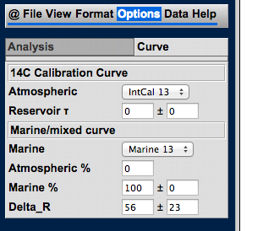

# Section 2: Calibration of multiple dates using the Input module.

### Data

Open the datasheet ‘Geissenklosterle_Higham et al. 2012’. These are a series of dates on bone from the Palaeolithic site of Geissenklosterle in southern Germany with Neanderthal and early modern human occupation levels.

### Ex2.1: How to open the Project Manager

* To open the Input module, press File => New. A new window displaying the input module will open.

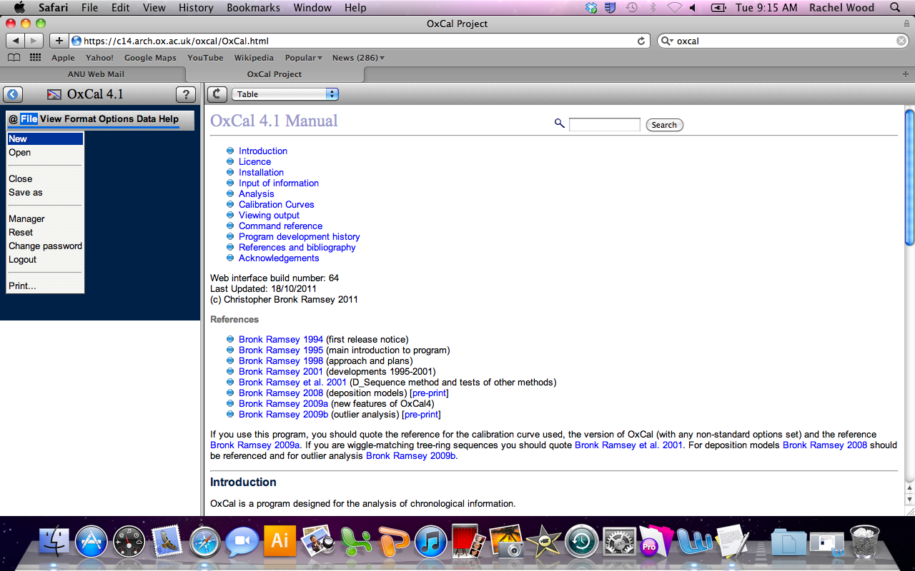

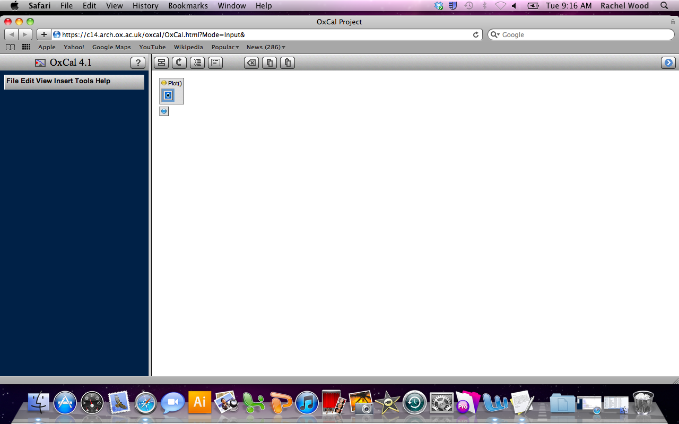

* Take a moment to look through the File Edit View Insert Tools menus. Some will look familiar, some not so.

### Ex2.2: How to enter multiple dates into the Project Manager

* Go Tools => Import

Check that you are set up to enter radiocarbon dates. In the CQL2 language, a radiocarbon date is an R_Date. Select this from the scroll down list beneath the main menu bar.

Copy and past the OxA-code Date and Uncertainty columns from the Excel sheet with the Riwi dates into the text box.

Click >>

Your dates should now appear in the right hand of the screen in the format R_Date(“Name”,14C Date, Uncertainty).

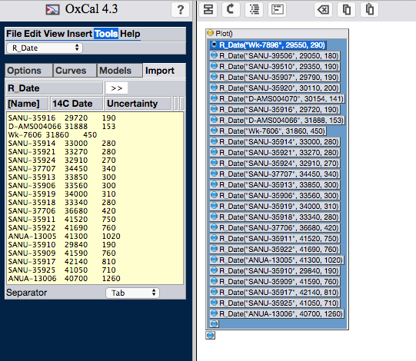

Riwi is in the Kimberley. Either SHCal13 or IntCal13 could be used here. Although it is just outside of the inter-tropical convergence zone, it is a long way from the New Zealand and Tasmanian trees and may not be as affected by the old carbon from the marine system. However, so far into the Pleistocene, the choice of curve is not so important as the difference between the two is only c.40 years. For practice, we will use SHCal13.

The instruction for which curve to use must go before the dates it applies to.

* Highlight the first date.
* Tools Curves and select SHCal from the drop down list.

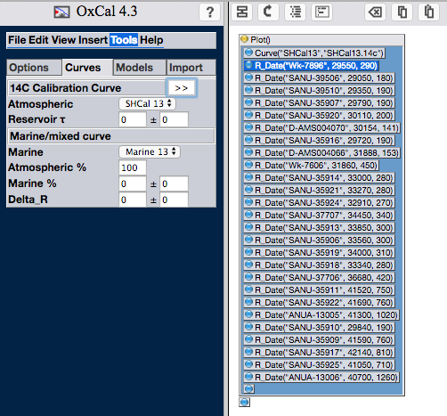

* To calibrate the dates, go to File => Run. When a second window opens, press Run again.

The calibration process is fast, so it is most likely you will see the results table in the Output module quite quickly. All of the menus are now identical to those you used to calibrate the single date.

* View your calibrated radiocarbon dates as a Multiple plot (under the View menu, this is called Plot dates).
* Try changing the view using the Zoom, Centre and Span buttons on the right hand side menu bar.
* The arrow, highlighted below will reverse the order of the dates (here making the oldest dates at the bottom).
* A more controlled way to change the view is to go to Format => Adjust. Then you can change the scale of the axes, the size of the font, the axis labels etc. To change the image style you must press the curly arrow button.

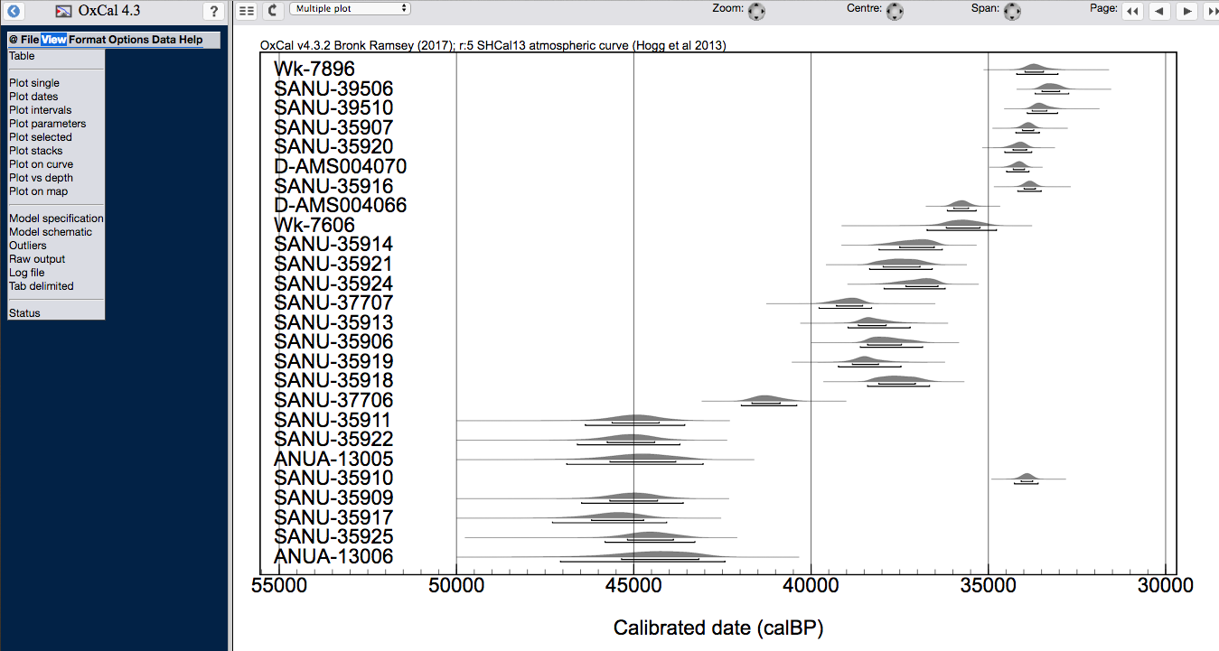

# Section 3: Production of a multiphase model

In this section you will produce a simple multiphase model of Riwi. Stratigraphically, the area of the site we are interested in is divided into 7 sedimentary units. The deepest, SU12mid, contains no archaeological activity. The stratigraphically deepest activity is represented by a hearth feature at the/on the top of SU12. Note that no ages were obtained from SU8. So we need to build a model consisting of a Sequence with 7 Phases separated by Boundaries. In a Sequence, events or Phases are ordered. The radiocarbon dates in a Phase bounded by 2 Boundaries are assumed to be evenly (or uniformly) distributed throughout time.

### Ex3.1: Input of a model

Models can be entered in manually or imported from a spreadsheet. I normally find fewer mistakes are made (and it is faster!) when the automatic input method is used, and then the code can be adapted for my own model if required.

* Produce a ‘skeleton’ mode
  + Open a new Input window (File => New)
  + Open the Tools menu
  + Select the SHCal13 curve from the ‘Curves’ submenu
  + Select Phases from the ‘Models’ submenu
  + Say you want 7 Phases
  + Make sure ‘sequential’ is selected. In a sequential model, 2 Boundaries are inserted between each Phase allowing there to be a discontinuity between stratigraphic units. Contiguous models have 1 Boundary between units, assuming a relatively continuous sedimentation. It is possible to have a mixture in your model, and you can try to see the effect of this later (for example, I think it is appropriate to have just one Boundary between SU12 mid and SU12 top)
  + Click >> to produce the model in the right hand pane.

Everything within the Sequence box will be ordered in the model. The **OLDEST** part of the Sequence is at the **TOP** and the **YOUNGEST** at the **BOTTOM**. This is the illogical (for archaeologists) part of OxCal.

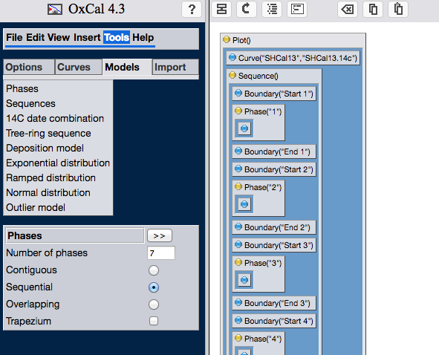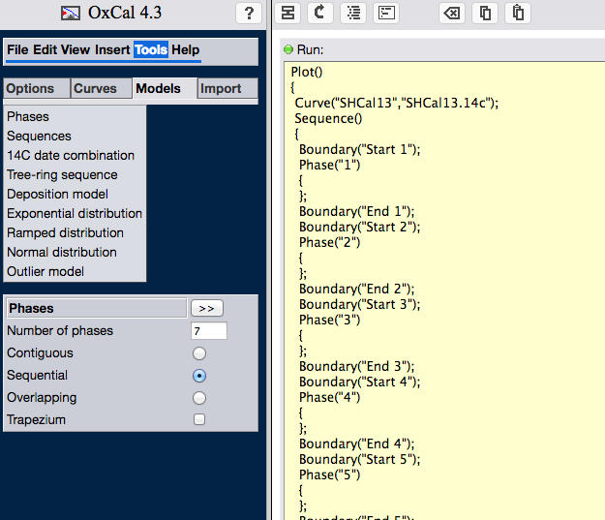

* Rename the functions:
  + Click on the 4th box along the toolbar on the right side of the screen. This takes you to a yellow box with the CQL code.
  + Change Boundary(“Start 1”) to Boundary(“Start 12 mid”). Make sure you do not change anything (including spaces and quotation marks) except what is between the quotation marks.
  + Label the names of the Phases and Boundaries appropriately.
  + Click on the first box in the tool bar (see image below) to return to the user-friendly box image.

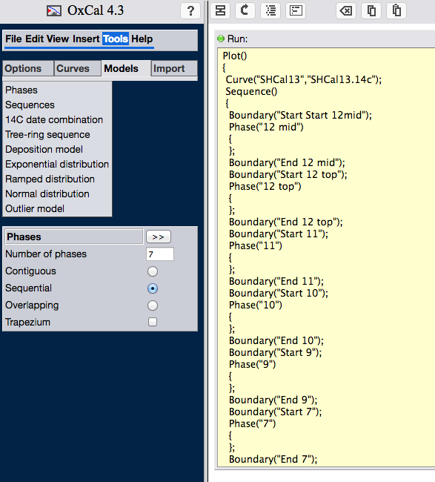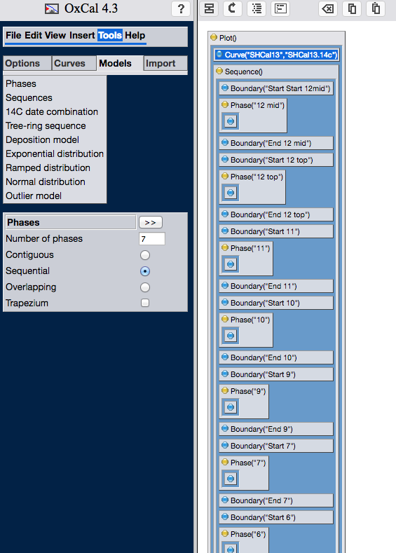

* Add the radiocarbon dates.
  + Select the blue bullet point in Phase 12 mid.
  + Go to Tools => Import and add the radiocarbon date from the Excel sheet from SU12 top as you did in section 2 by clicking >>. Remember to check you are importing R_Date.
  + Put the radiocarbon dates from the other layers in the Excel sheet into your model.

If you miss-spell something, you can highlight the relevant box, go to Edit => Edit and the CQL code fragment will be displayed. Change the bit that needs to be changed before pressing OK.

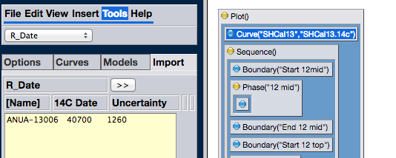

* Where you have multiple dates on one sample use R_Combine.

R_Combine calculates the weighted average of the uncalibrated ages, allowing the average to be calibrated and incorporated into the model.

* + Go to Insert and select R_Combine from the dropdown list. Make sure you highlight the location in the model where you wish to transfer the function. In [Name] type a name for the sample/dates, leave [Systematic] blank, and >>.
  + Then you can add the dates as you were doing before. Go to Tools, Import. Make sure R_Date is selected from the drop down list, and that you have clicked the blue button inside the R_Combine box, and move your dates across.

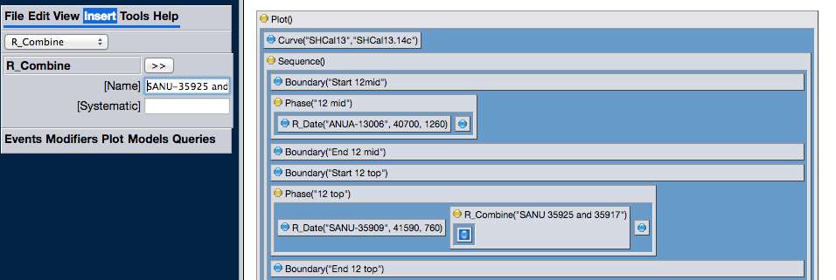

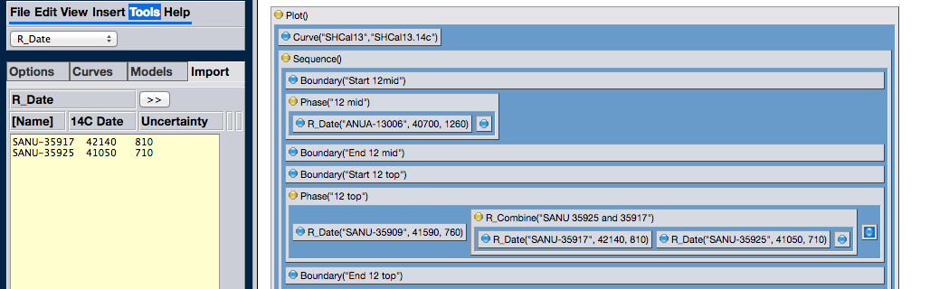

You should end up with this:

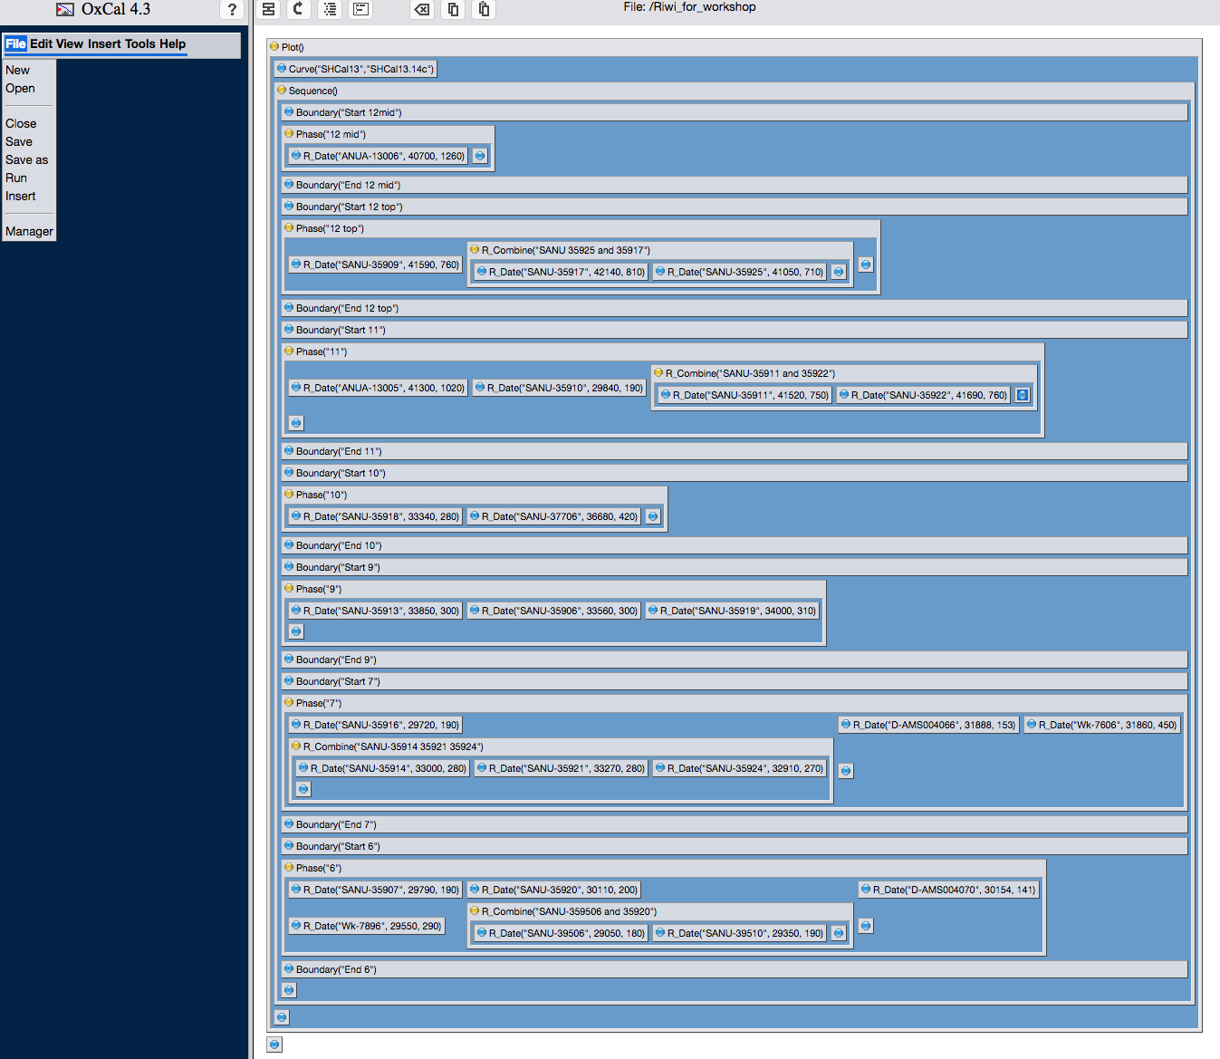

### Ex3.2: Saving your input file

* Save your model (File => Save as).

This is saved online, so when you login again, the model will be present

### Ex3.3: Outlier analysis

Often there are unexpected outliers in a radiocarbon dataset – even before we acknowledge problems with e.g. bioturbation at sites and contamination of samples, statistically we would expect 1 in 20 (or 5%) of our dates to fall outside their quoted 95.4% error range. In OxCal these dates can be identified by the model and then down-weighted according to how likely they are to be an outlier. So if a date is found to have a 50% chance of being an outlier it is only included in 50% of the model iterations. If it is found to have a 5% probability of being an outlier it is included in 95% of the model iterations.

In OxCal you need a model to describe how you think the outliers are distributed (Outlier_Model), and assign a prior probability that the individual radiocarbon dates are outliers (Outlier).

Normally, it is assumed that each date has a 5% chance of being an outlier (a little arbitrary, but you can change this value and see if it affects your model). The most common model used is the General t-type Outlier Model. This model is very flexible. It draws the outlier from a student T distribution with five degrees of freedom, the scale of the offset is allowed to range between 1 and 10000 years, essentially allowing the program to determine the scale of the offset. The student T distribution is bell-shaped like the normal distribution, but with longer tails to account for extreme outliers. There are many other outlier models in OxCal, and a full description is given in Bronk Ramsey, 2009b. Bronk Ramsey et al. 2010 also contains descriptions and is easier to read.

* Insert the Outlier Model at the start of your model.
  + Click on Sequence to highlight (so that the command will be placed before the Sequence box.
  + Tools => Models => Outlier model and select **General** from the scroll down list. The values should be distribution T(5), scale U(0,4) and type t.
  + >> to insert

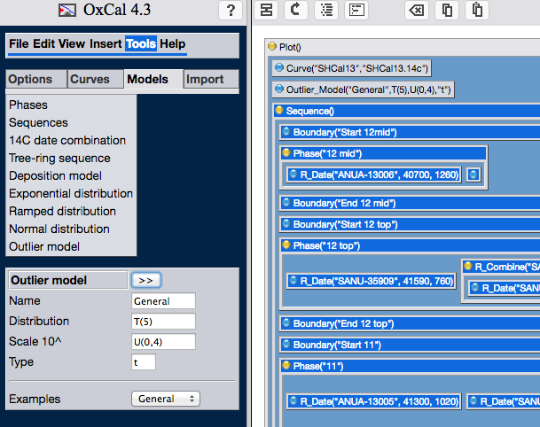

* Now you need to assign each date a probability of 0.05 (or 5%) of being an outlier
  + Highlight a R_Date.
  + Insert, select Outlier either from the scroll down list, or Modifiers. In Probability, type 0.05. Leave Name blank.
  + Press >>.
  + Repeat for all radiocarbon dates.
  + Where you have used R_Combine, the outlier probability should go within the R_Combine box rather than the individual dates. To do this highlight the box before you move the outlier probability across. (Note that other Outlier Models can be used for Combined dates, but this is outside the scope of this workshop).
  + OxCal performs a Chi squared test on dates within the R_Combine function, and will give a warning if this fails.

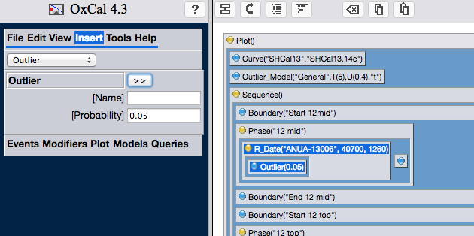

Your model should look like this:

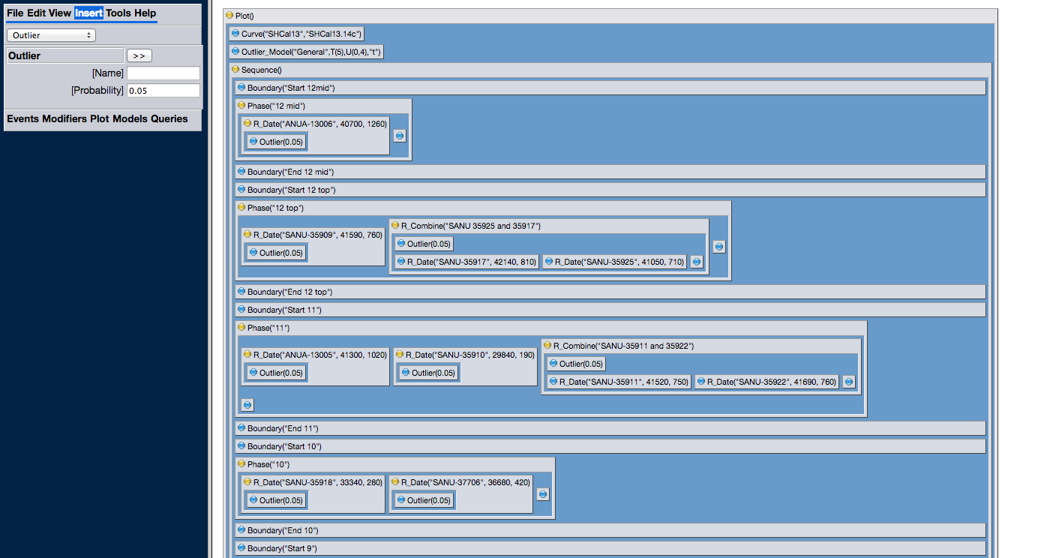

### Ex3.4 How to run a model

* Run the model (File => Run).

You will see the Analysis module. Riwi is not a ‘perfect workshop’ model, and you may well see some red warnings flash when it is running. Hold on, and don’t panic yet. This is just a warning that the MCMC is struggling to converge, which is often the case for larger models. For this model, in 2-3 minutes the warnings should stop.

Usually the model should be run until it is ‘Done’. However, we are short of time, so as soon as you have 100,000 or more Passes, the convergence bar has some blue in it, and the warning signs have stoped, press the red button in the top left hand corner to stop the analysis module. (It is useful to do this whenever running a model for the first time, just to check the model is likely to run and there are no typos. For publication of most models, let them run for at least an hour before stopping, or set it going over night, and it should have finished by the following morning).

YOU CAN CLOSE THE PROGRAM AND REOPEN LATER. THE MODEL WILL CONTINUE TO RUN. You can also run multiple models at the same time.

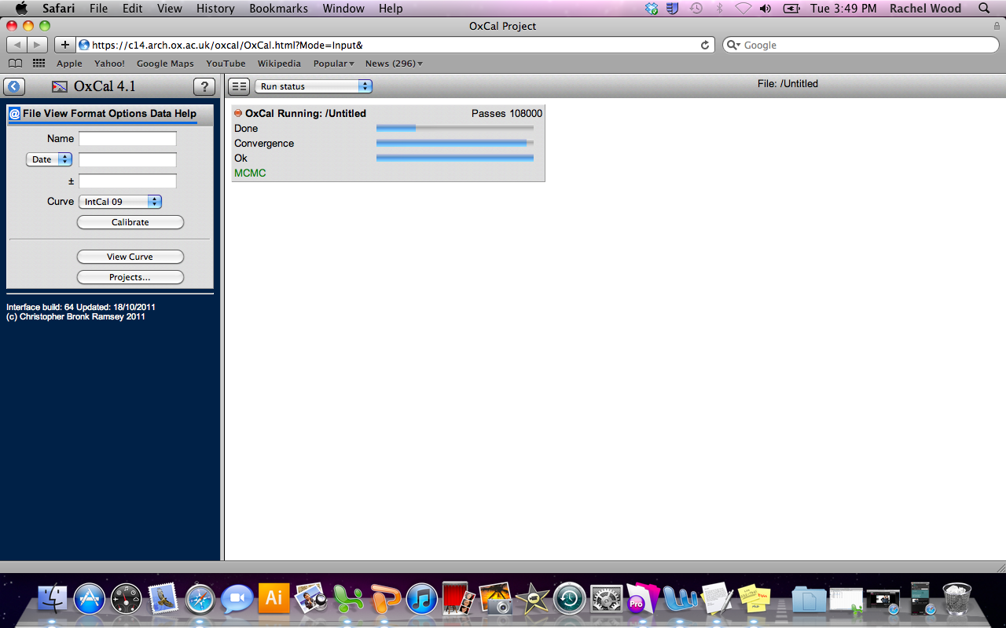

# Section 4: Viewing and assessing the model

You should now see the Table view in the Output module. Both the unmodelled and modelled dates should be shown. (If not, go to Format => Show and check that Likelihood and Posterior both have a tick next to them).

The calibrated dates (Unmodelled) should be the same as the person next to you. The Modelled dates may differ slightly.

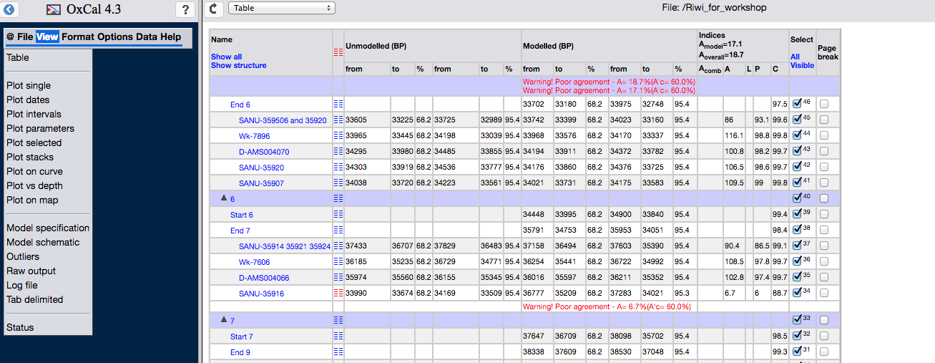

Also have a look at an image of the dates. If the modelled probability distributions (PDFs) are jagged, the model has not run for long enough, or the model may be struggling to converge as the dates are compatible with your prior assumptions.

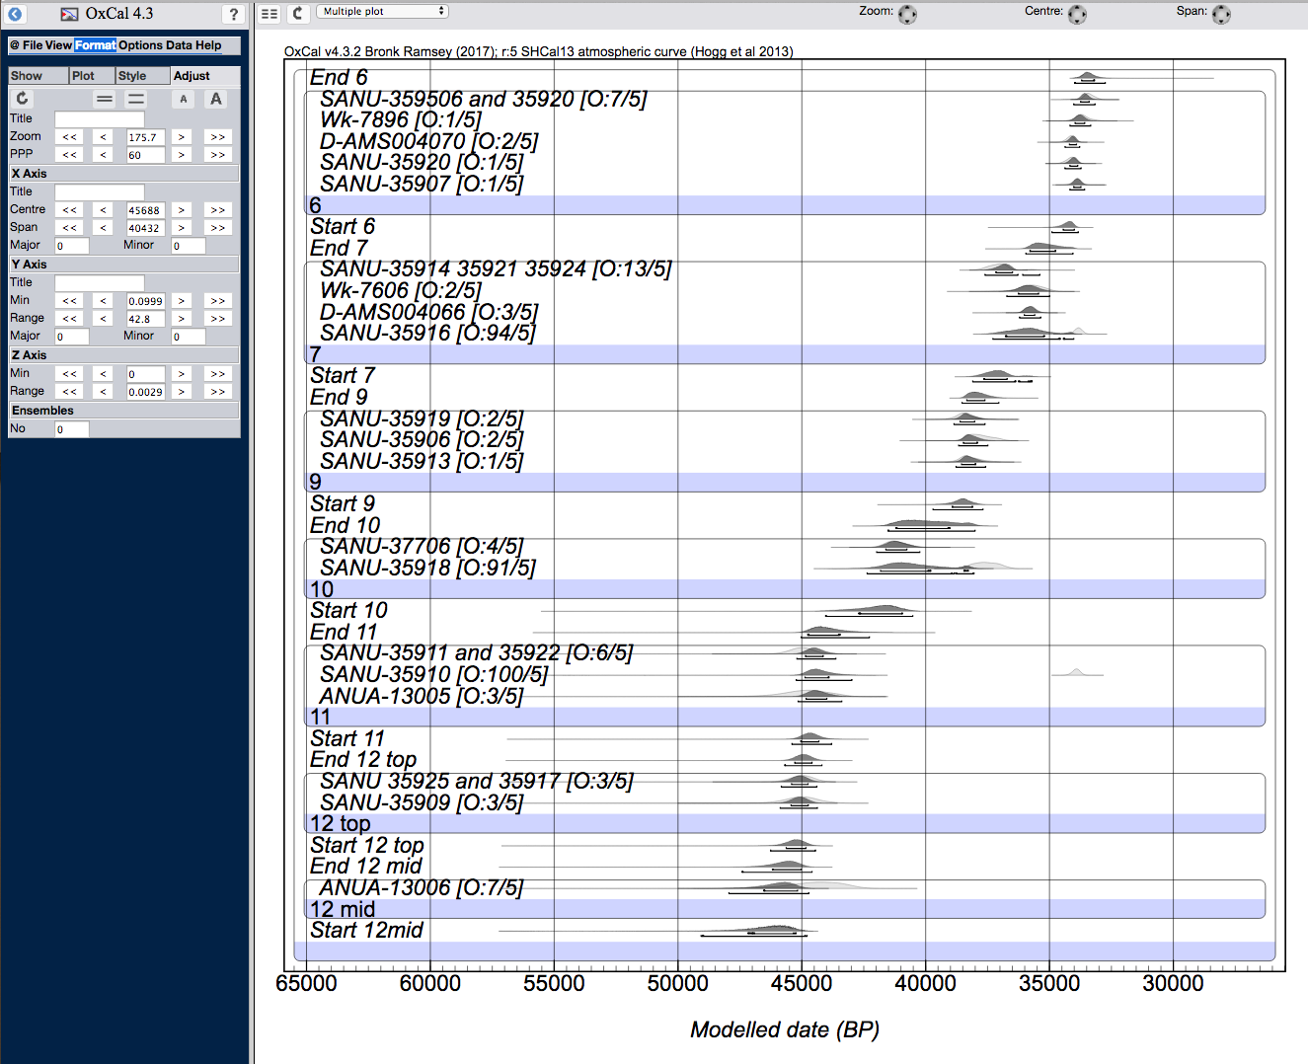

**Convergence**: The convergence integral (C) tests whether the MCMC analysis has provided a representative posterior probability distribution by examining how similar different attempts to perform to analysis are. It should be above 95% (arbitrary cut-off). This is given in the column labelled “C”.

* Check that C is above 95% for all radiocarbon dates. (Note that the first and last Boundary in a model may have lower convergence – this is OK)

**Agreement Index**: This provides a measure of the agreement between the model (prior) and the data. If you have used an Outlier Model, you do not need to consider this index. In the Geissenklosterle example, you will get warnings about poor agreement. However, you have used an outlier model, so you do not have to worry about them to much.

***Sensitivity testing****: For complicated models, it is important to test whether the model is biasing our results in an unexpected way by systematically modifying priors to assess their impact on the model outcome. There is not time to cover this here, but the two references to examples given below are excellent examples.*

BAYLISS, A., BRONK RAMSEY, C., VAN DER PLICHT, J. and WHITTLE, A., 2007. Bradshaw and Bayes: Towards a timetable for the Neolithic. *Cambridge Archaeological Journal,* **17**(1 (suppl.)), pp. 1-28. (or any other article in this volume).

BRONK RAMSEY, C.B., DEE, M.W., ROWLAND, J.M., HIGHAM, T.F.G., HARRIS, S.A., BROCK, F., QUILES, A., WILD, E.M., MARCUS, E.S. and SHORTLAND, A.J., 2010b. Radiocarbon-based chronology for dynastic Egypt. *Science,* **328**(5985), pp. 1554-1557.

**Outlier analysis**:

There are two ways to view results of the outlier analysis:

1. Look at the multiple plot. You will see [O:2/5] after the sample name. This means you assigned a 5% prior outlier probability, and the model found a 2% posterior outlier probability so the sample was included in 98% of the model runs and so influenced the model outcome. If this number is not present on your plot, go to Format => Plot and tick Outliers, and press the curly arrow.
2. View => Outliers. The red bars represent the posterior probability of the date being an outlier – i.e. how much the model found the date to be outlying.

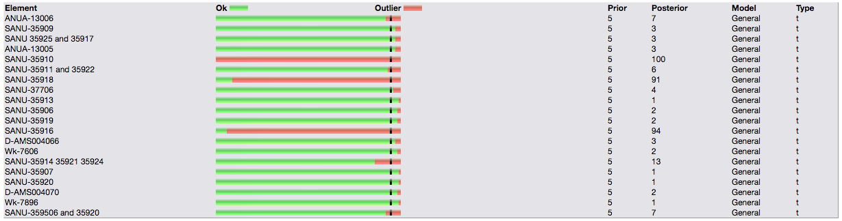

# Section 4: Interpretation of the model

Construction of the model is just the start. We don’t have much time to go into this here, but it is a useful exercise to use what you have learnt in this class to assess whether you think the chronology of human occupation at Riwi is robust and what could be done to improve it. For example,

* Why are some charcoal samples outlying? Are they affecting the model?
* Does the calibration curve choice impact the model outcome?

Etc.

# Section 5: Age depth models (P_Sequence)

Age-depth models in OxCal assume a Poisson (or random) accumulation of sediment (Ramsey, 2008, Ramsey and Lee, 2013). You can think of this like a rain gauge; every drop of water will increase the depth by a specific amount. A small drop will increase it less, a larger drop more. If all drops are small there will be a smoother accumulation, and vice versa. In terms of the model, this means that the equivalent of a smaller grain will lead to a smoother rate of deposition that larger grains and there will be less uncertainty in age between radiocarbon dates. This factor is called the ‘k value’ in OxCal. In the past it needed to be chosen by the user, but it is now calculated from the data by averaging the model over many values of k (Ramsey and Lee, 2013).

### Ex5.1 Lynch’s Crater

Use data from: Turney et al Lynchs crater C14. Data is arranged in 4 columns; lab code, date, error, depth. Lynch’s crater is in Queensland, and we will use SHCal13. All dates are on bulk peat.

* To build a deposition model
  + Open a new Project: File => New
  + To input the model code automatically: Tools => Models, then select Deposition Model
  + Give your model a name
  + Copy and paste the Lab code, conventional age, error and depth from the spreadsheet. Note that the youngest is now at the top.
  + Select Poisson distribution. This will automatically fill several boxes below. Check that they are appropriate for your use. The points you are most likely to change are:
    - Interpolation rate (this is how many modelled dates you will have per unit length)
    - Unit of depth (cm by default)

If you have good prior information about the deposition processes in your core, you may also be able to specify:

* + - Poisson parameter, k0. By default this is set to 1 cm.
    - log10(k/k0). By default this is set to U(-2,2) which allows for variation by two orders of magnitude in either direction.
  + If you want to include Outlier Analysis, enter the model you want (normally General t-type) and the prior outlier probability (normally 0.05).
  + Then transfer to the right hand panel: >>.
* Save (File, Save As)
* Run (File, Run)

Note that the deepest date is now at the top of the code.

The code looks similar to the Sequence model we looked at before, but

* the command P_Sequence is used rather than Sequence
* there are no Phases in the model. This means that everything within the P_Sequence box is arranged from deepest to shallowest. Now the dates themselves are arranged in order
* A Boundary constrains the top and bottom of the P-Sequence

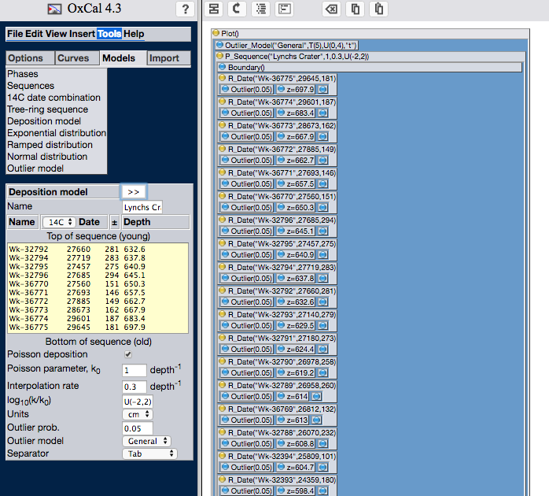

For now, stop the analysis after more than 100,000 passes (by pressing the red button in the top left).

To view the data:

* Check the Depth Plot by View => Plot vs depth.
* Note that the axis are opposite to Bacon
* The dark blue distribution represents the 68.2% probability range, and the light the 95.2% range
* I find it useful to have quick visual check that distributions are smooth and that the outlier probabilities are reasonable before looking at the Table in more detail.
* Check the Table by View => Table, or by clicking the icon
* Check convergence is >95%
* Check that there are no error warnings.

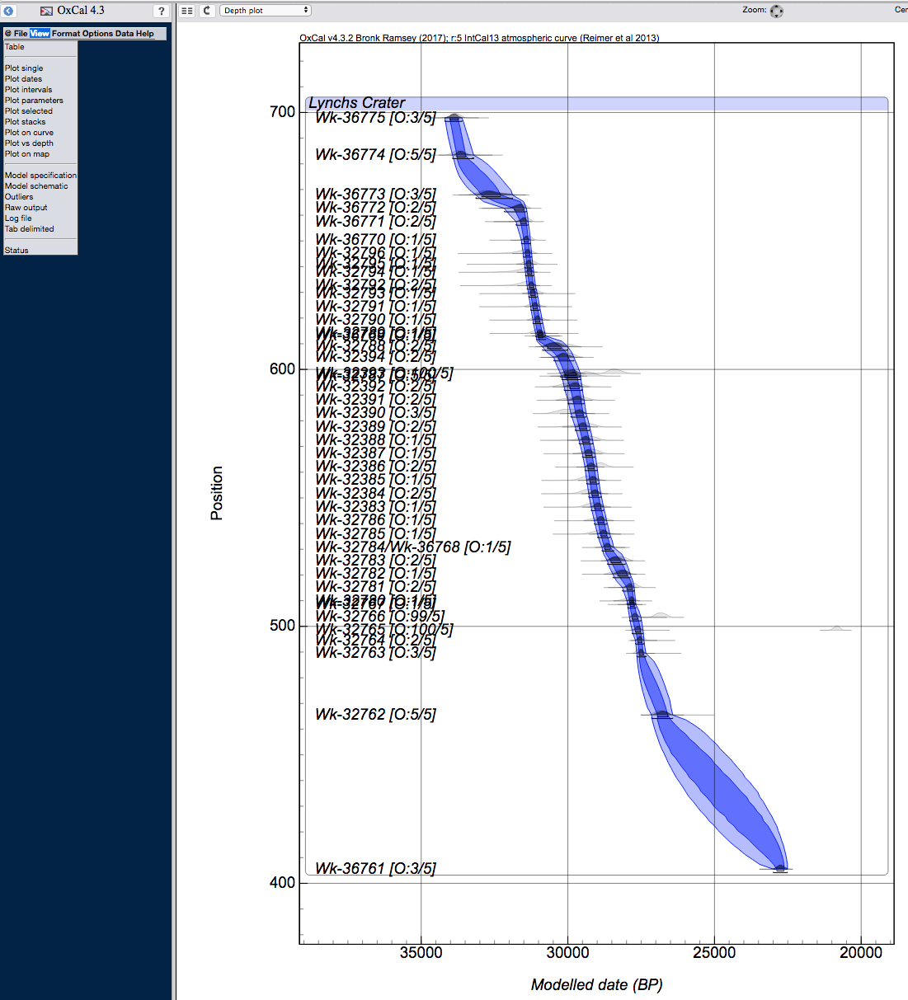

You may want to use the mean or median for plotting a pollen diagram etc.

* To view the mean and standard deviation: Format => μ and Median.

The table will only give you modelled ages for the dates.

* To obtain the ages for specific depths,
  + click on  next to P_Sequence(1,0.5,U(-2,2)). .
  + Under Depth Plot you can Save a .csv file with a modelled age for each depth. Please note that it is not appropriate to use these for anything but plotting the e.g. pollen data. When considering when changes in pollen abundances change, the full error term should be considered.

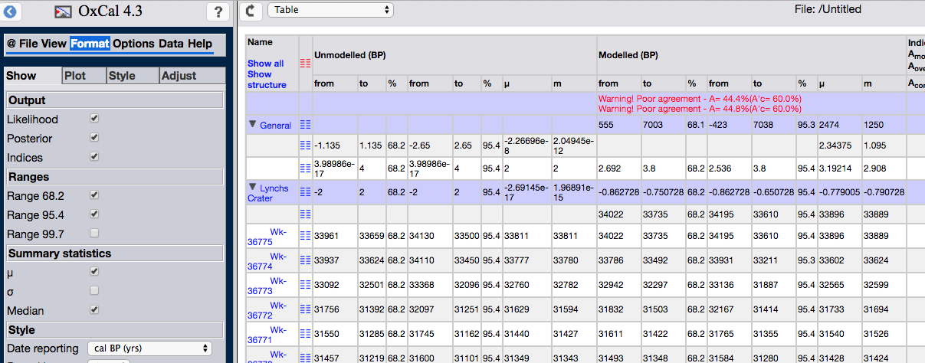

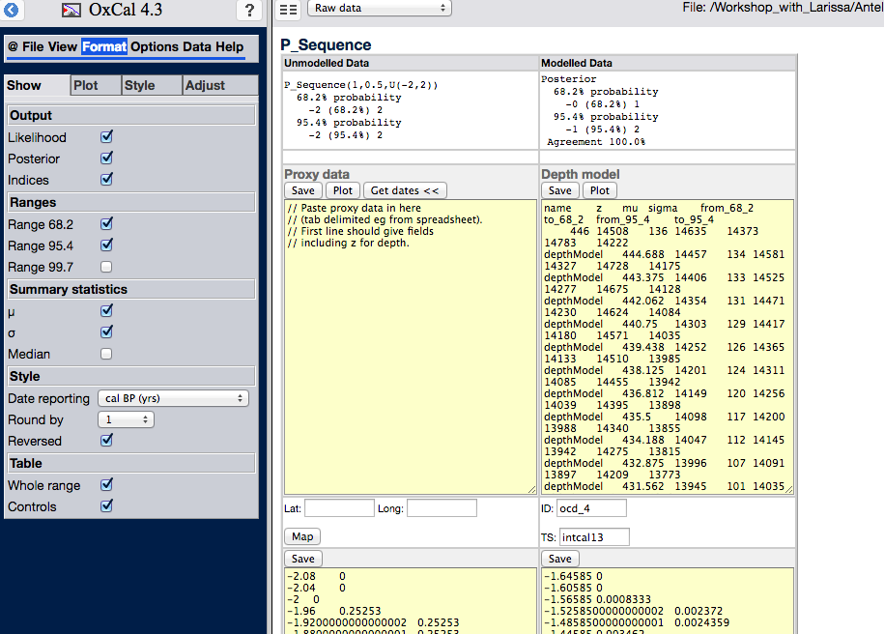

Using the instructions in the Proxy data field, it is possible to plot your proxy data in OxCal against the calculated age model, to obtain an image which includes the modelled uncertainty.

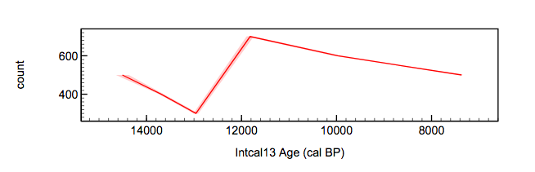

# Section 6: Model Queries

We won’t go through this in the workshop, but I’ve included it in the handout for future reference as it is not covered in the OxCal Help menu and is not intuitive.

Now you have your model, you might want to ask it some questions. There are several questions you can ask in OxCal, one of the most common being how long a Phase lasted (you need to use the Interval function). For your assignment, I want you to compare two Boundaries to see if one is significantly earlier than another. To do this, we need to subtract one Boundary from the other using the Difference function. If zero lies within the 95.4% probability range they are the same, if it does not, they are different (see explanatory box).

The Difference Function

The Difference function can be used to assess whether two probability distribution functions (PDFs) are identical. An example is given in SOM figure 1. Three hypothetical Boundary PDFs are given, A, B and C (figure 1a). The 95.4% probability distributions of all PDFs overlap, but some overlap more than others. It is clear that A and C overlap by only a tiny probability, but at what point can we call the PDFs ‘different’ at some degree of significance? Figure 1b shows the Difference between the Boundaries. The Difference between A and B (example 1) overlaps with zero, but examples 2 and 3 do not. In this paper we have said 2 and 3 are different at 95.4% probability.

Figure 1; An example of the Difference function in OxCal. a) Three hypothetical Boundary PDFs b) The Difference between the Boundaries. Examples 2 and 3 would be considered different at 95.4% probability, example 1 would not.

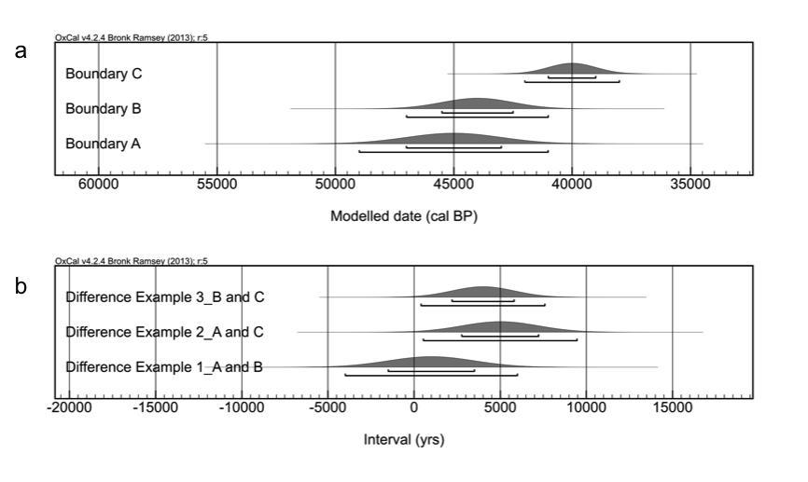

To do this in OxCal the two Boundaries we are interested in need to be saved and inserted into a new File. This is a little longwinded to actually do, but follow the instructions and you’ll get there.

1. Go to the table view View => Table
2. In the second column of the table, click on this symbol . It might take a while, but wait for OxCal to take you to a new page.
3. Click on the Save button (if you have a “/” in your Boundary name you will get a message saying a directory does not exist. This is OK, just click through it). Give it a reasonable name. The PDF will be saved as a “.prior” file automatically.

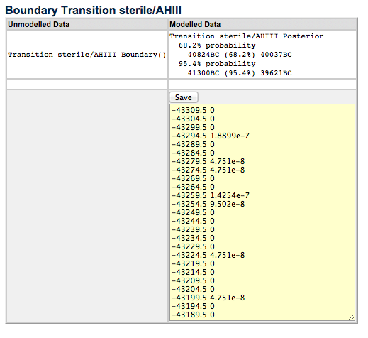

1. Open a new file (File => New). Save the file (File => Save As).
2. In the new file, File => Insert (note, the Insert button in the header bar is not a short-cut).
3. Find your Boundary file, select (click on it and its name should appear) and Insert (bottom left). If you can’t see your file, make sure “Priors” is selected in the drop down list.

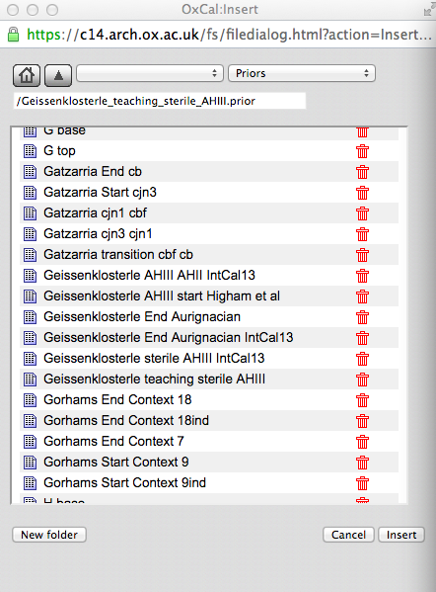

1. Go to the CQL (yellow box) view. (remember: click on  in the header bar on the right hand panel).
2. You should see the following code:

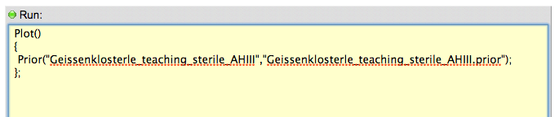

We need to tell OxCal that this PDF is a Date. Insert “Date(“ before “Prior….” and “)” after “)”, e.g.

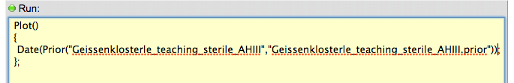

DO NOT CHANGE ANYTHING ELSE, INCLUDING THE NUMBER OF SPACES

1. Go back to the box view (click )
2. Check it looks like this (if not, you’ve deleted or added something to the code. Close the file and start again…).

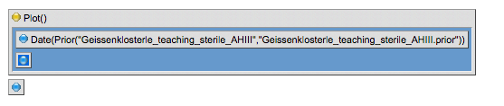

1. Follow steps 1-3 to save the second Boundary you are interested in, and then follow steps 5-10 to insert it into this file. E.g.

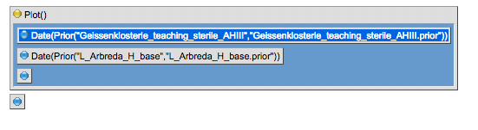

1. You are now ready to subtract one Boundary from the other. In the header bar in the left hand panel, click Insert (not File, Insert). In the drop down list, select Difference.

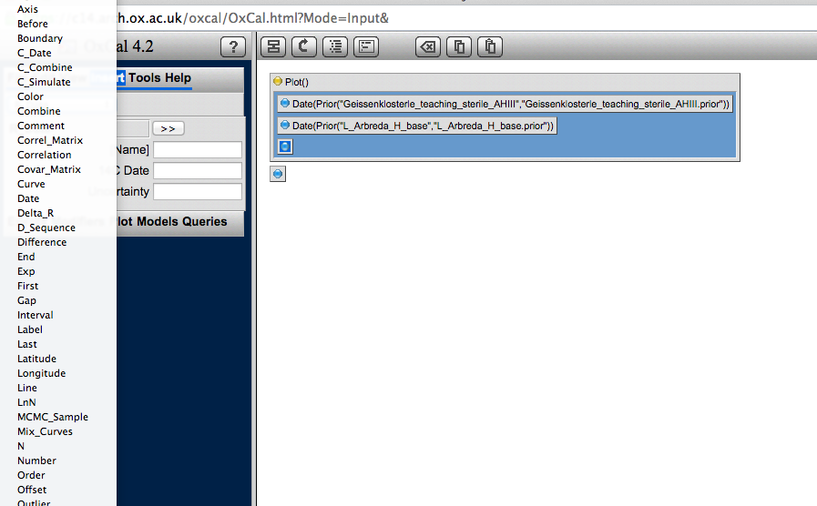

1. Give the command a name.
2. In Parameter 1 put the name of one Boundary, and in Parameter the name of the other. It doesn't matter which way round they go. Note, the names need to be identical to the name of the .prior file. To avoid needless frustration, copy and paste (as in the box below).

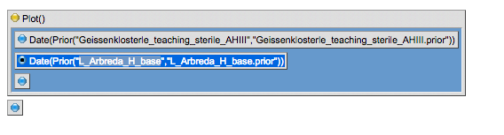

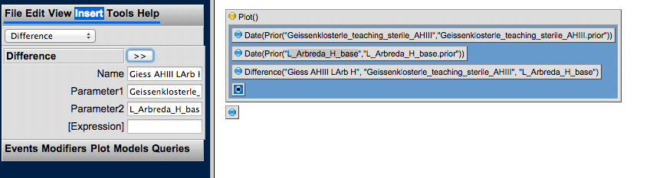

1. Add to the bottom of the code by selecting the single dot and clicking >>.
2. Save (File => Save).
3. Run (File => Run).
4. In my example the two are indistinguishable at 95.4% probability as the Difference is

-2551 – 305 calibrated years. We cannot say that one is earlier than the other.

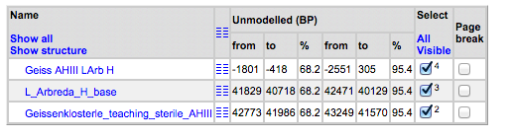

Further reading for future reference

The OxCal online manual (just skim it to get an idea, and look at when you have a specific problem)

BAYLISS, A., 2009. Rolling out revolution: Using radiocarbon dating in archaeology. *Radiocarbon,* **51**(1), pp. 123-147. (Good intro)

BRONK RAMSEY, C., 2009a. Bayesian analysis of radiocarbon dates. *Radiocarbon,* **51**(1), pp. 337-360. (this is quite complicated – don’t start here if you have not studied a lot of maths!)

BRONK RAMSEY, C.B., 2009b. Dealing with outliers and offsets in radiocarbon dating. *Radiocarbon,* **51**(3), pp. 1023-1045. (complicated, but useful)

BRONK RAMSEY, C.B., DEE, M., LEE, S., NAKAGAWA, T. and STAFF, R.A., 2010a. Developments in the calibration and modeling of radiocarbon dates. *Radiocarbon,* **52**(3), pp. 953-961. (good description of outlier analysis in OxCal).

* Examples are also useful to look at to get an idea of what to use the programme for, and how to test it.

BAYLISS, A., BRONK RAMSEY, C., VAN DER PLICHT, J. and WHITTLE, A., 2007. Bradshaw and Bayes: Towards a timetable for the Neolithic. *Cambridge Archaeological Journal,* **17**(1 (suppl.)), pp. 1-28. (or any other article in this volume).

BRONK RAMSEY, C.B., DEE, M.W., ROWLAND, J.M., HIGHAM, T.F.G., HARRIS, S.A., BROCK, F., QUILES, A., WILD, E.M., MARCUS, E.S. and SHORTLAND, A.J., 2010b. Radiocarbon-based chronology for dynastic Egypt. *Science,* **328**(5985), pp. 1554-1557.

* When you come across some dates in your reading or work, just give it a go to get comfortable using it.

Deposition models:

Ramsey, C.B., 2008. Deposition models for chronological records, Quaternary Science Reviews 27, 42-60.

Ramsey, C.B., Lee, S., 2013. Recent and planned developments of the program oxcal, Radiocarbon 55, 720-730.